Written Report: Bias Project
AP Statistics
Mrs. Peters

November 30, 2011
Block 2B
Aralee Fajardo, Melody Sarno, & Royce Ramos
Introduction
The form of response bias our group is investigating is "Does anonymity change the responses to sensitive questions?" Our first question that will be asked not anonymously is "If you saw a girl crying in the hallway and you had just heard the minute bell, would you ask her what's wrong?" The second question will be asked anonymously. We chose this question because we felt it would show the type of bias correctly. We believe that more people would answer yes to the question when asked not anonymously because the subject will feel held accountable by their peers. These are the results that we expect.
Method
A systematic sample with a random start will be used to conduct this survey. The attendance sheet to Ms. Walker's 3A class (GSWLA Government) will be numbered (each student receives a number in alphabetical order). A student in the class will be chosen randomly with a random number generator. Every five students from that chosen person will be surveyed. (This will be done not anonymously) In Mrs. Lacks' 4A class (Global Connections), this procedure will be done again as in Ms. Walker's class. The only difference is that a different start number will be chosen with a random number generator. The question this time will be asked anonymously.

Results
Number of those answered yes (anonymous) | Number of those answered no (anonymous) | Number of those answered yes (NOT anonymous) | Number of those answered no (NOT anonymous)
2 | 7 | 4 | 5

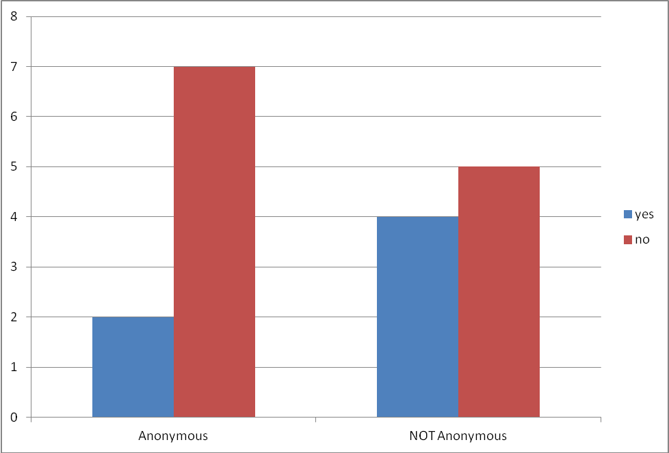

Conclusions
Concluding, when asked the question anonymously, moor people honestly answered because they knew they wouldn’t be held accountable for their response by their peers. This can be concluded by the data that only 2 out of the 9 students surveyed would stop in the hallway to help the girl that was crying. This is further concluded by comparing it to the other 9 students asked not anonymously. When held accountable by their peers, 4 of those students responded that they would indeed help the girl. This shows how anonymity affects the results of a survey. The results were as anticipated, where students who are asked not anonymously, would feel held accountable by their peers for doing what they believe their peers would think as the right thing. During the project, the problem we encountered was the number of students absent on the day we conducted the survey, so we had to revise our method of surveying. Instead of numbering an attendance sheet, asked the students to write their answers on a slip of paper including their name for the not anonymous, and not including heir name of course for the anonymous. Something different we would do is we would broaden our testing population and possibly block the students up by female and male to decrease the effect of the confounding variable of sex of a person. Learned form this project, bias is really difficult to get rid of and confounding variables can sway your results. We also learned that it is very difficult to gain a true response when surveying, because some of the surveyors want to skew the results and others want to answer based on what they feel the surveyor wants the response to be. In all, this project was very informative in showing us that bias is a serious issue in surveying and everything should be done to eliminate it so that the numbers can be directly represented.

